

**Tribhuvan University**

**Faculty of Humanities and Social Sciences**

A Lab REPORT

Of

Cloud Computing

**Submitted to:**

**Department of Computer Application**

**Damak Multiple Campus**

*In partial fulfillment of the requirements for the Bachelors in Computer Application*

Submitted by

Sandip Chapagain

(TU Symbol No: 6-2-202-885-2019)

March, 2024

Under the Supervision of

Pradip Ghimire

## Acknowledgement

The lab work report has been prepared in the partial fulfillment of course “**Cloud Computing“** of Seven semester of Bachelor of art in computer application while preparing this report, I got a lot of co-operation and suggestion from different persons.

I am thankful to **Mr.Pradip Ghimire** (subject teacher) for properly guiding me. I also want to thank my friends who helps me a lot in the lab work.

I would like to express my hearty thanks to my family member who provided inspiration and motivation regularly for my success.

## Certificate

This is to certify that the lab report entitled Software Cloud Computing is an academic work done by Sandip Chapagain submitted in the partial fulfillment of the requirements for the degree of Bachelor of Computer Application at Faculty of Humanities and Social Science ,Tribhuvan University under my guidance and supervision. To the best of my knowledge, the work performed by him in the lab report is his own creation.

Signature

Table of Contents

Acknowledgement i

Certificate ii

Lab 1: Install vmware and create two virtual machines(window and linux) on your system. 1

Lab 2: Installation and configuration of esxi server 11

Lab 3: Configuring security policies and roles in vsphere/esxi 20

Lab 4: Case Study: Pass(facebook,google app engine) 24

Lab 5: Case Study:amazon web services 26

# Lab 1: Install vmware and create two virtual machines(window and linux) on your system.

**Objective:** To install vmware and create virtual machine

**Requirements:** 8GB Ram, 100 HDD, i5 Processor, vmware and ISO file

**Procedure:**

Step 1: Download vmware workstation from the official website and install it on your machine

Step 2: Download windows 10 iso and ubuntu iso

Step 3: Launch the vmware and follow these steps

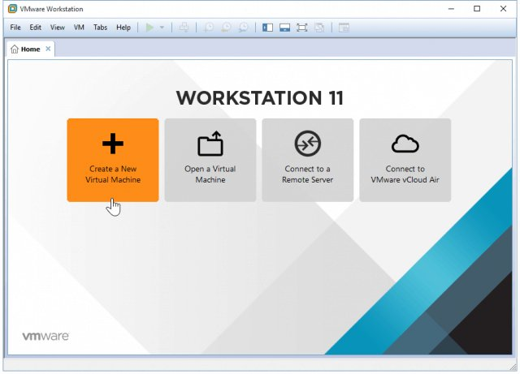

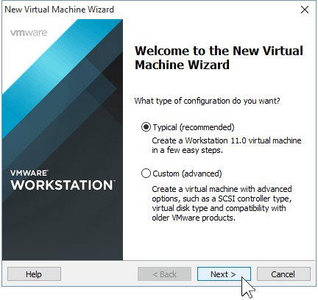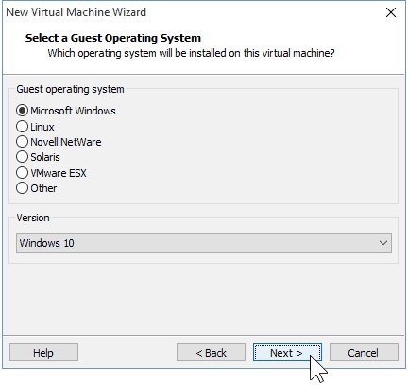

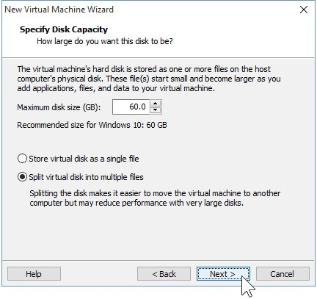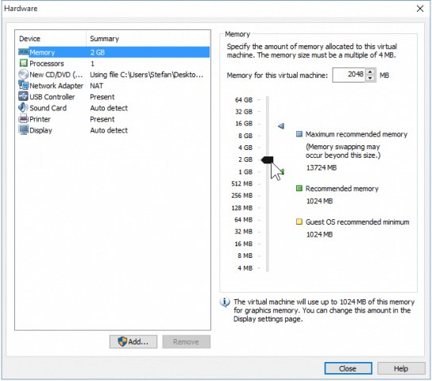

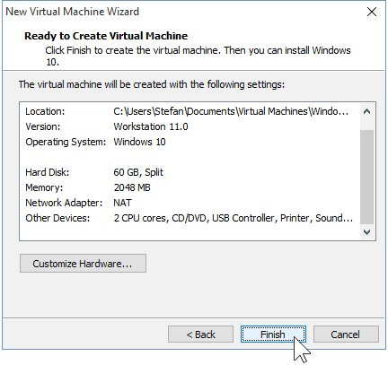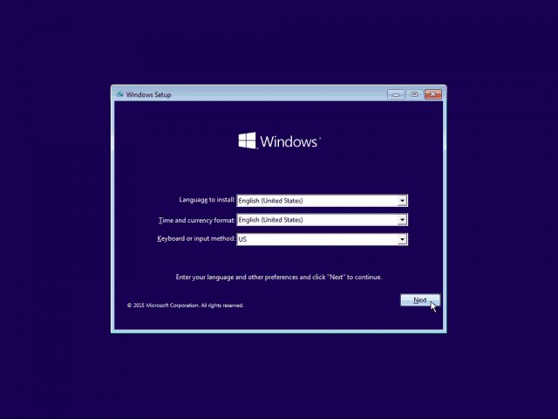

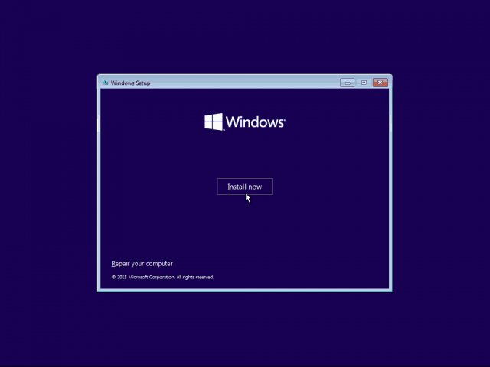

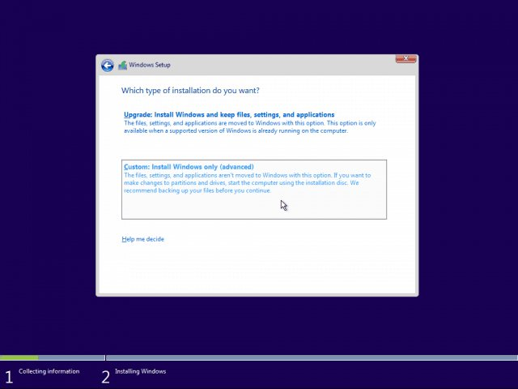

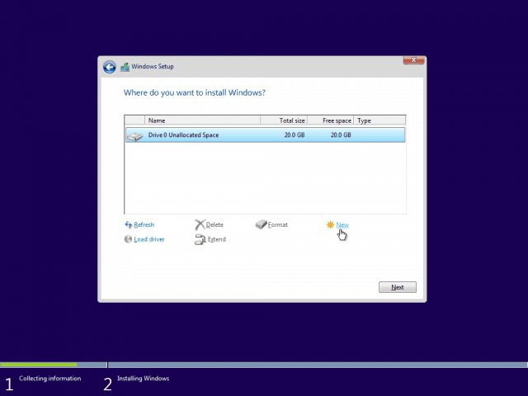

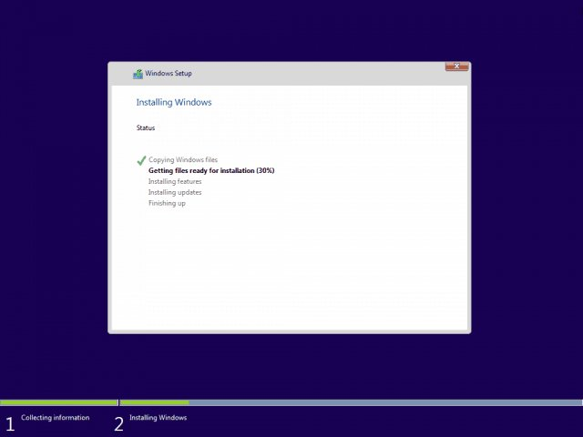

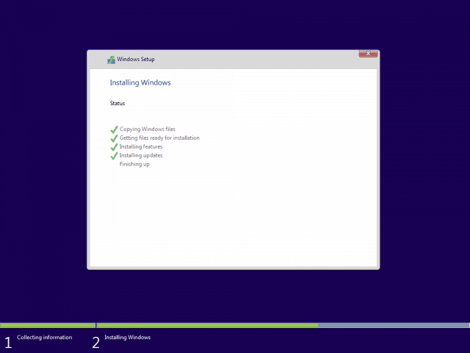

**For Ubuntu**

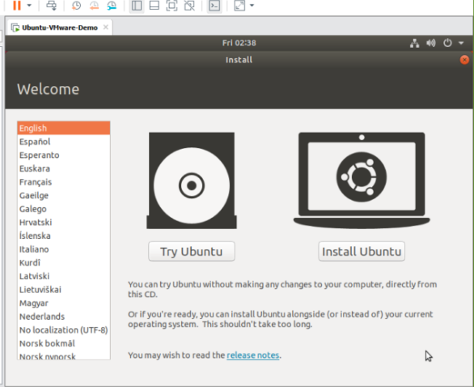

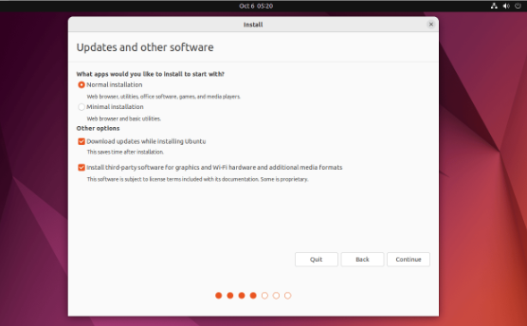

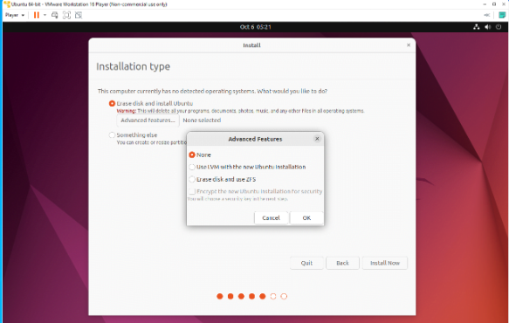

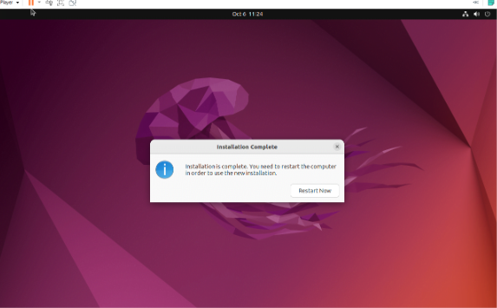

# Lab 2: Installation and configuration of esxi server

**Objective:** To install and configure esxi server

**Requirements:** 8GB Ram, 100 HDD, i5 Processor,

**Procedure:**

Step 1: Download the vmware sphere (esxi server)

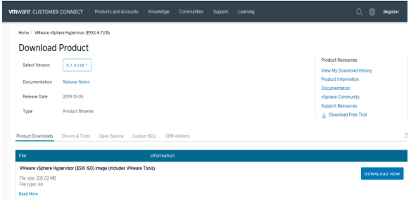

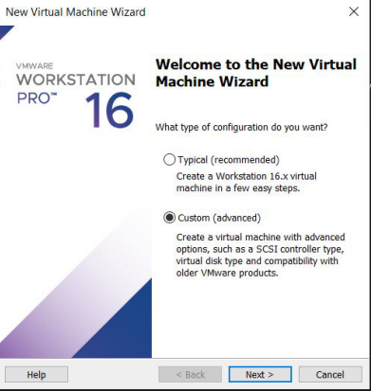

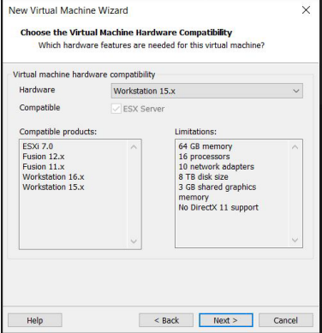

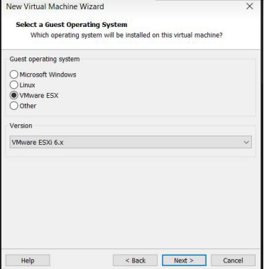

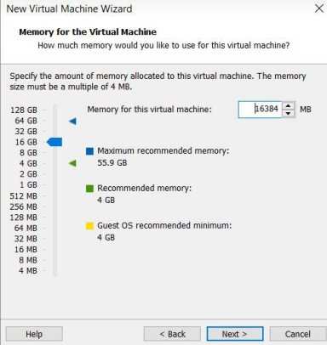

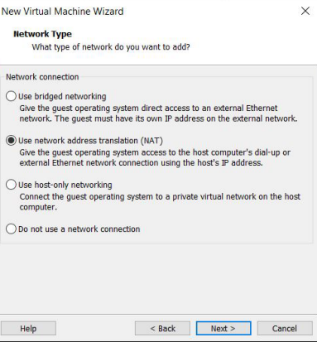

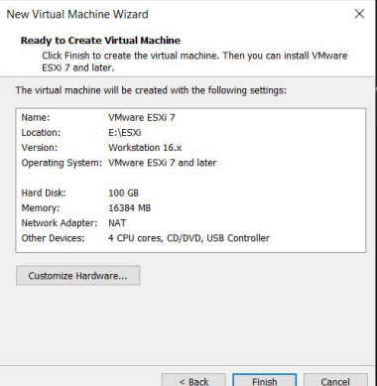

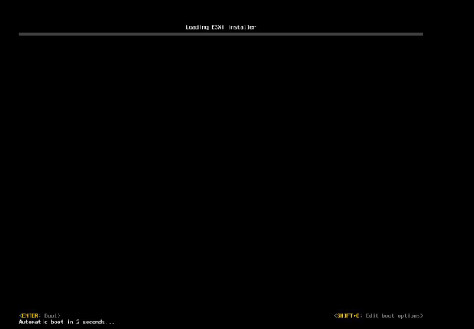

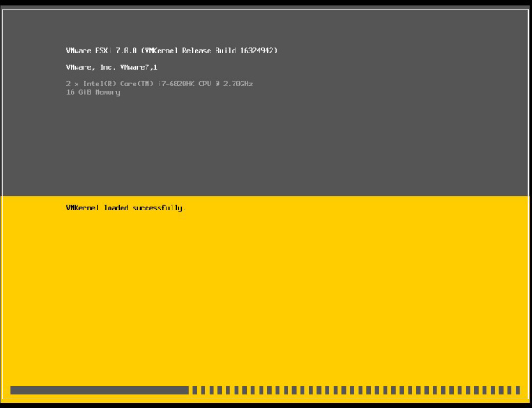

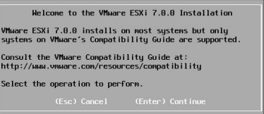

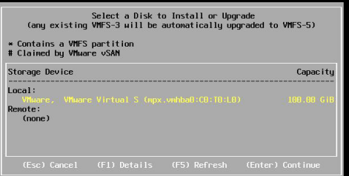

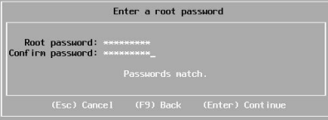

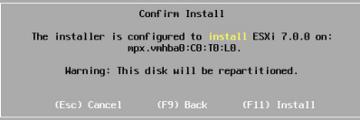

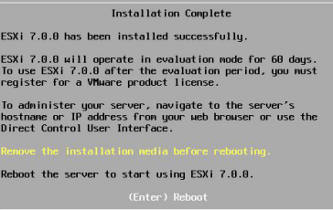

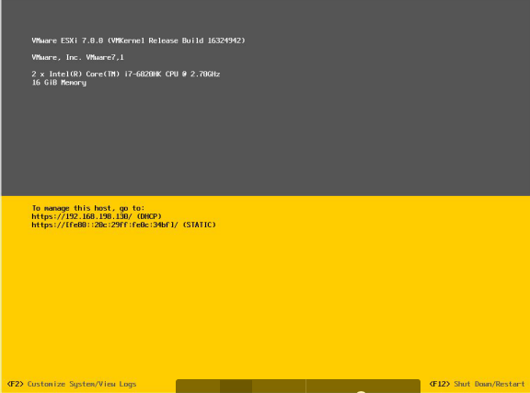

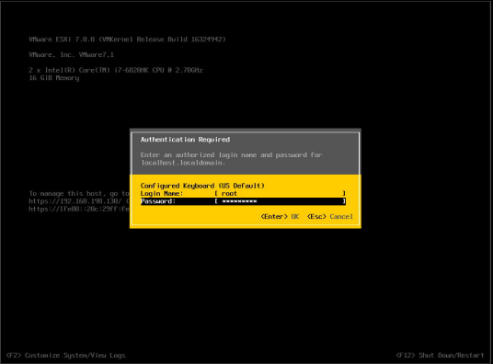

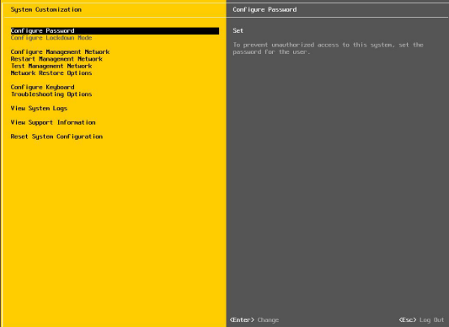

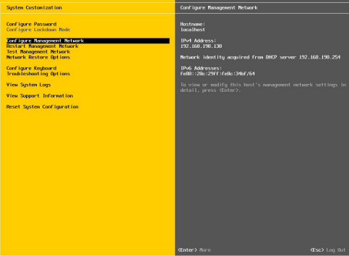

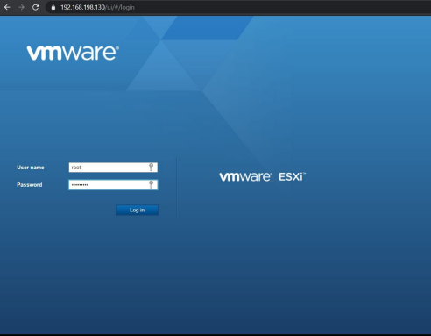

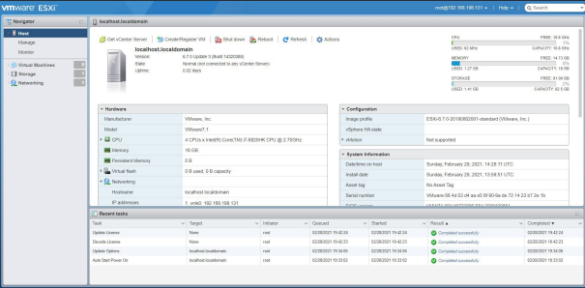

# 

# Lab 3: Configuring security policies and roles in vsphere/esxi

**Objective:** To configure security policies and roles in esxi server

**Requirements:** 8GB Ram, 100 HDD, i5 Processor,

**Procedure:**

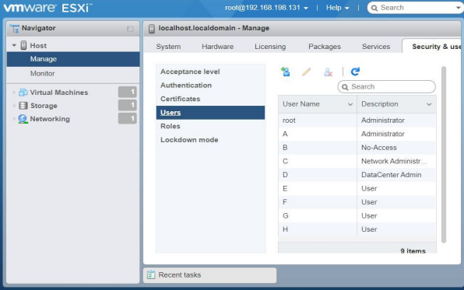

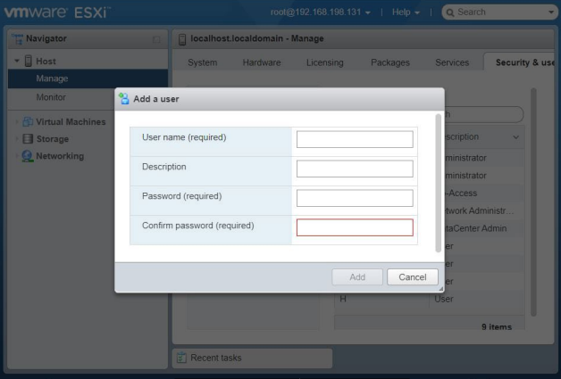

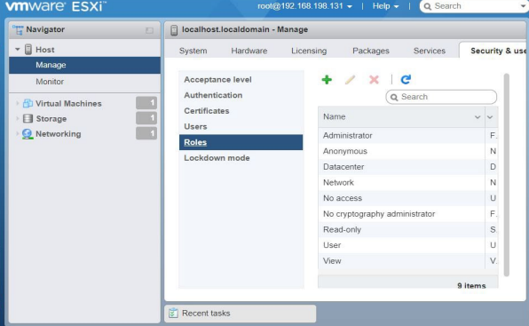

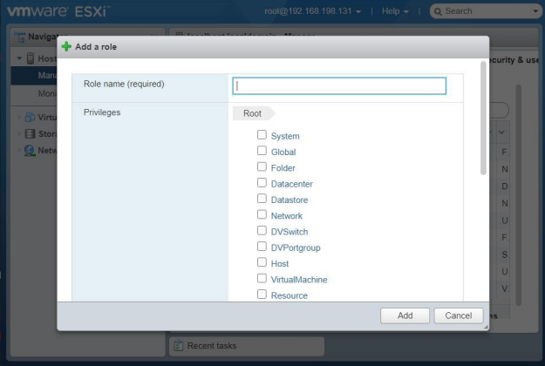

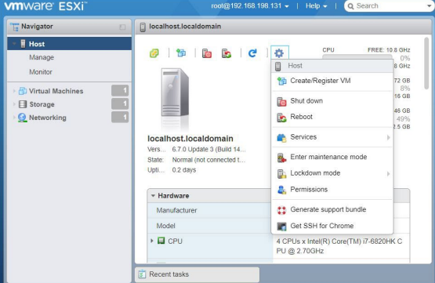

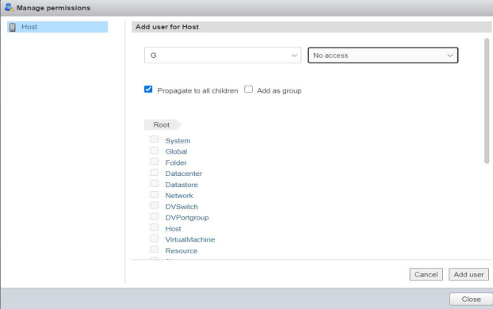

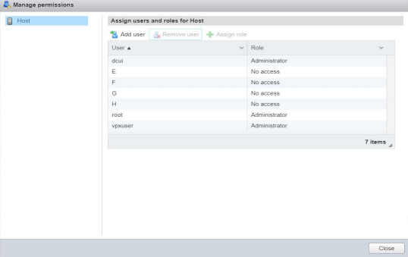

## Lab 4: Case Study: Pass(facebook,google app engine)

## Lab 5: Case Study:amazon web services